**Deployment Plan of a LoRa Mesh Network**

Contents

**Summary** 1

**Node location study** 2

**Phase 1: Test phase deployment** 4

Point (1) 5

Point (2) 6

Point (3) 7

**Production phase deployment** 8

Point (1) 10

Point (2) 11

Point (3) - Backup 12

Point (4) 13

Point (5) - Backup 14

Point (6) 15

Point (7) - Backup 16

Point (8) 16

## **Summary**

There will be a two-phase deployment:

1. Phase 1: Test

**Where**: One Pool Street building  
**How many**: 3 points total in OPS.  
**Locations:** can be found in the last section.  
**Until when**: getting permission to deploy in the park.

1. Phase 2: Production

**Where**: The Olympic ParkandOne Pool Street building  
**How many**: 8 points total: 4 in QEOP, 3 in QEOP as a backup (not to be used unless needed), 1 in OPS building.  
**Locations:** can be found in the last section.  
**Until when**: dissertation submission.

## **Node location study**

According to the [heatmap test](https://loramesh.yaman-ka.com/Experiments/Experiment3/Results/heatmap/) I did, LoRa mesh nodes can communicate easily on a line of sight, but when it comes to ground with different heights, things [could get more complicated](https://smartmakers.io/en/lorawan-range-part-2-range-and-coverage-of-lorawan-in-practice/).

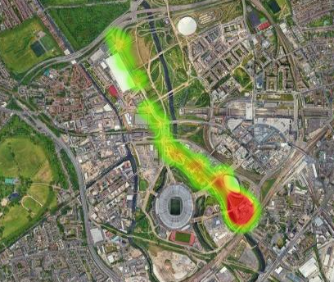

Figure 1 – Point-to-point LoRa RSSI test

The main difference between CASA’s past deployments and this deployment is the dependence on the industrial gateway positioned on the orbit. This gateway is positioned almost 100 meters above the ground, where in this dissertation, the nodes will be maximum 3 to 4 meters above the ground.

This means a topographic study must be done on the park to ensure the nodes are positioned in the right places to give acceptable coverage, taking in mind the cost factor of course.

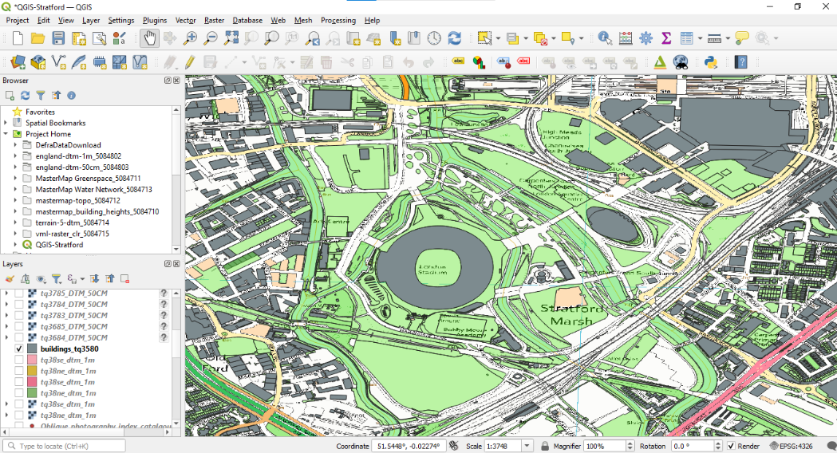

Figure 2 – QGIS program was used to understand building heights.

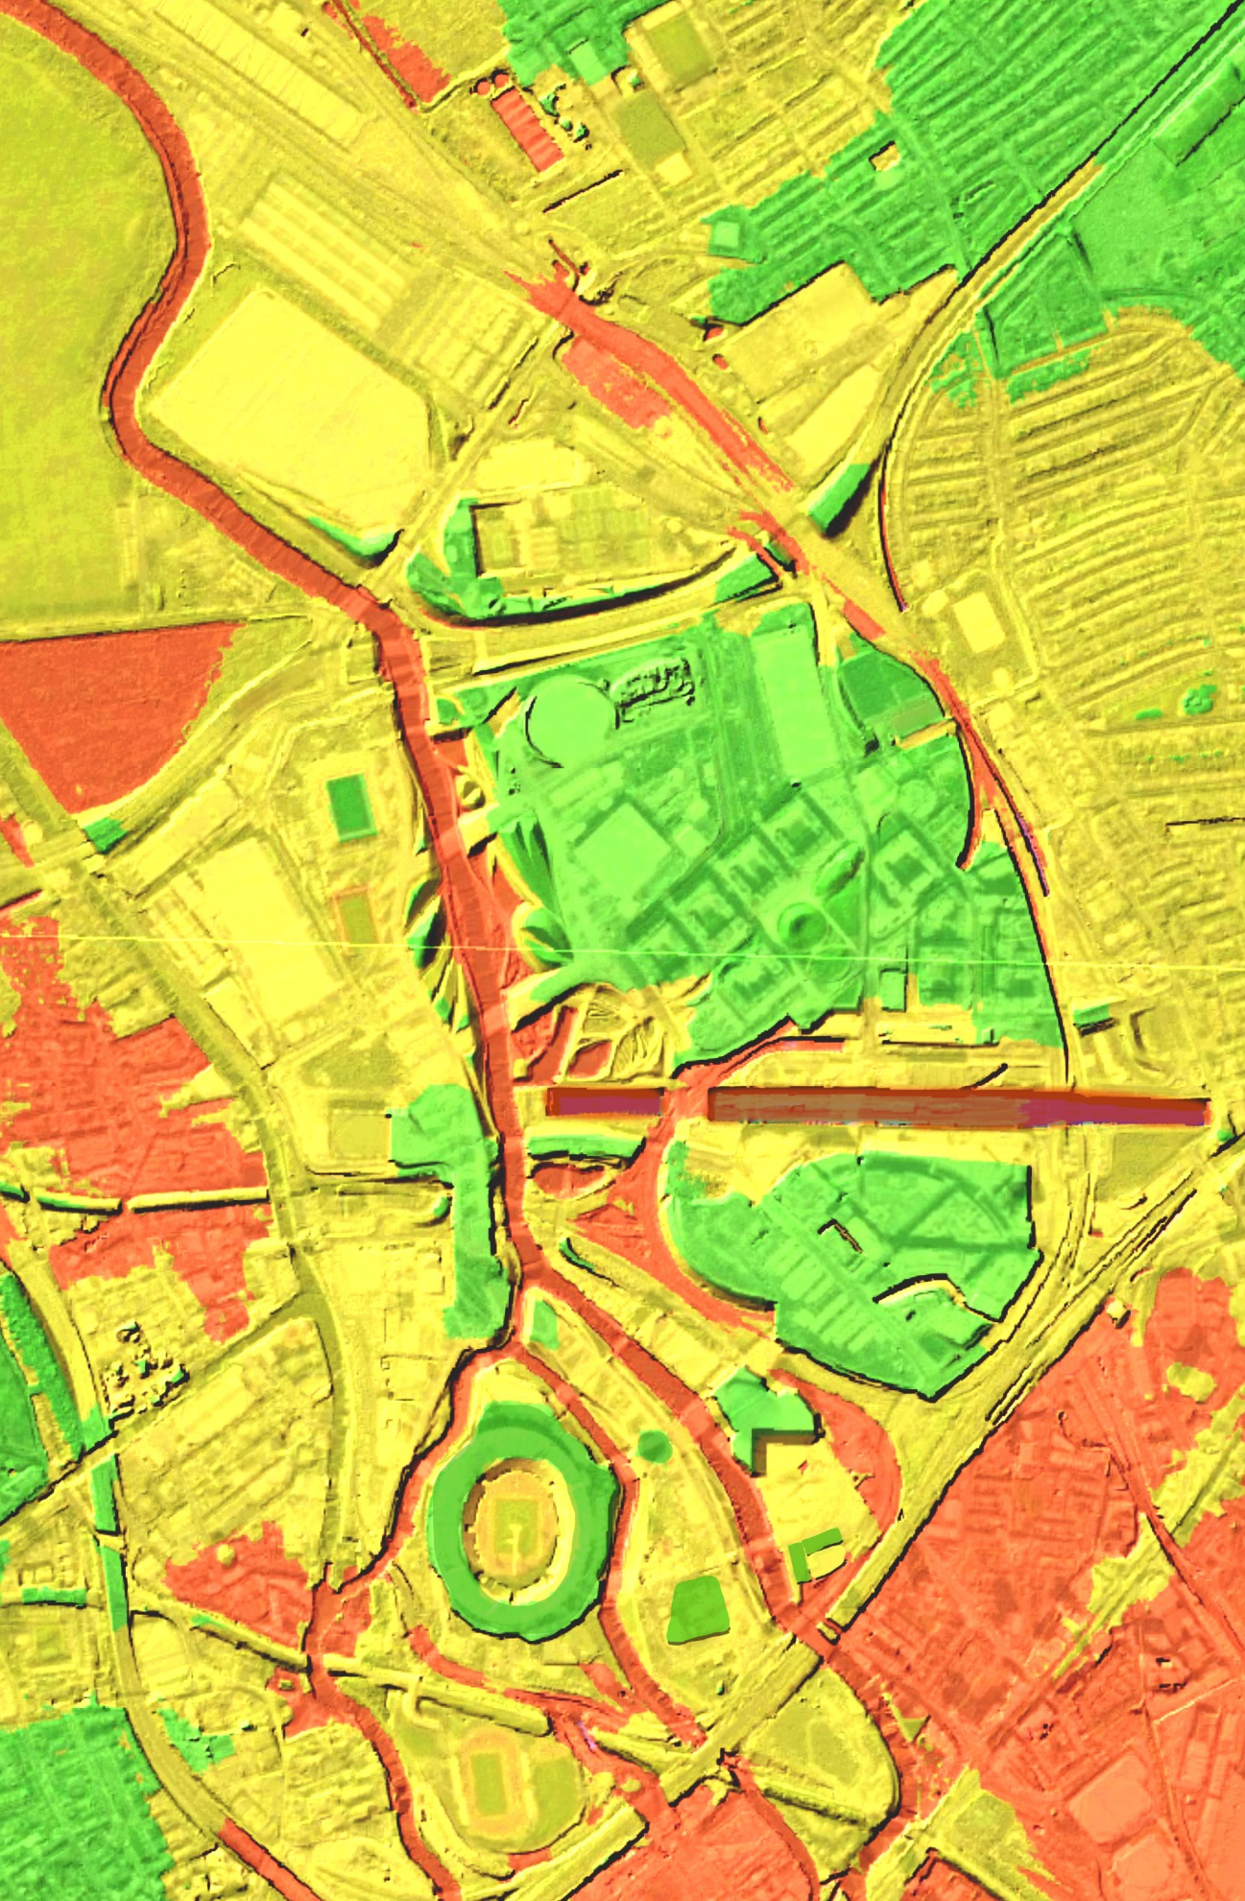

Figure 3 – A [Topographic scan](https://environment.data.gov.uk/image/rest/services/SURVEY/LIDAR_Composite_2m_DTM_2022_Elevation/ImageServer) of Stratford and QEOP areas using LIDAR  
(**Green** colour is the highest elevation, **Red** is the lowest)

## **Phase 1: Test phase deployment**

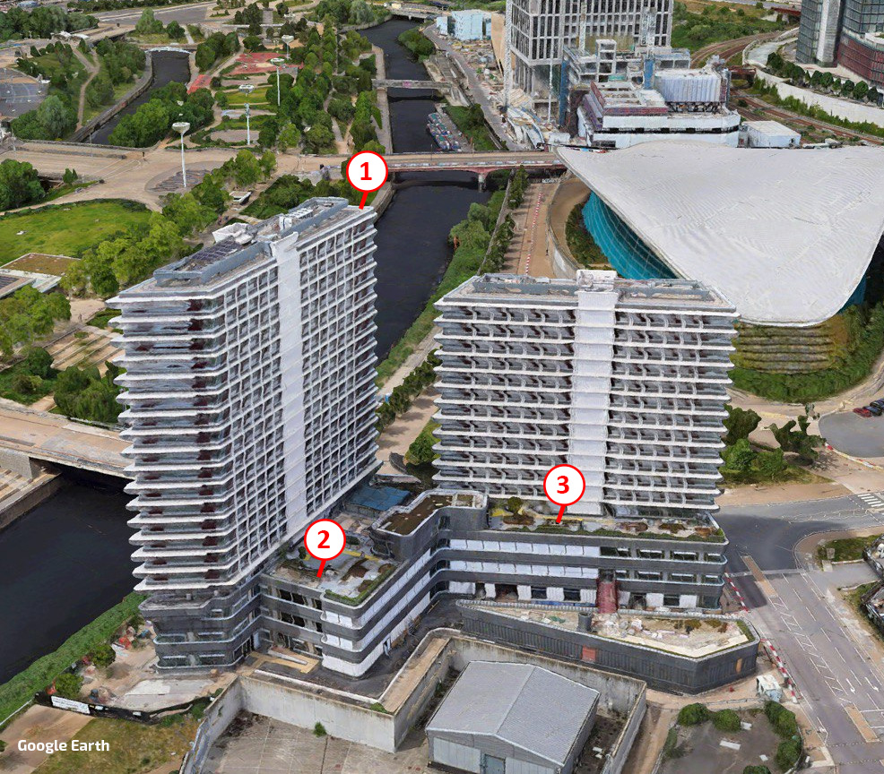

Figure 4 – Test phase deployment in OPS

### Point (1)

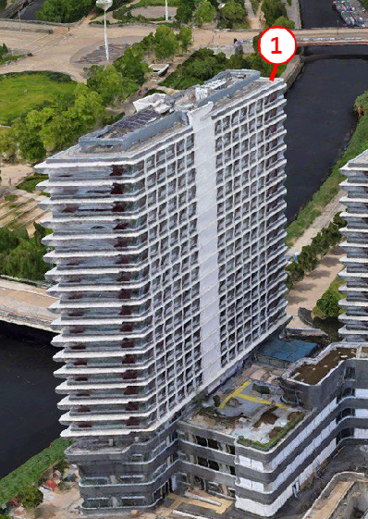

Figure 5 – Point 1 on Tower 1

On the roof of Tower 1, to overcome the elevation challenges. **This node is to be left there during the production phase.**

### Point (2)

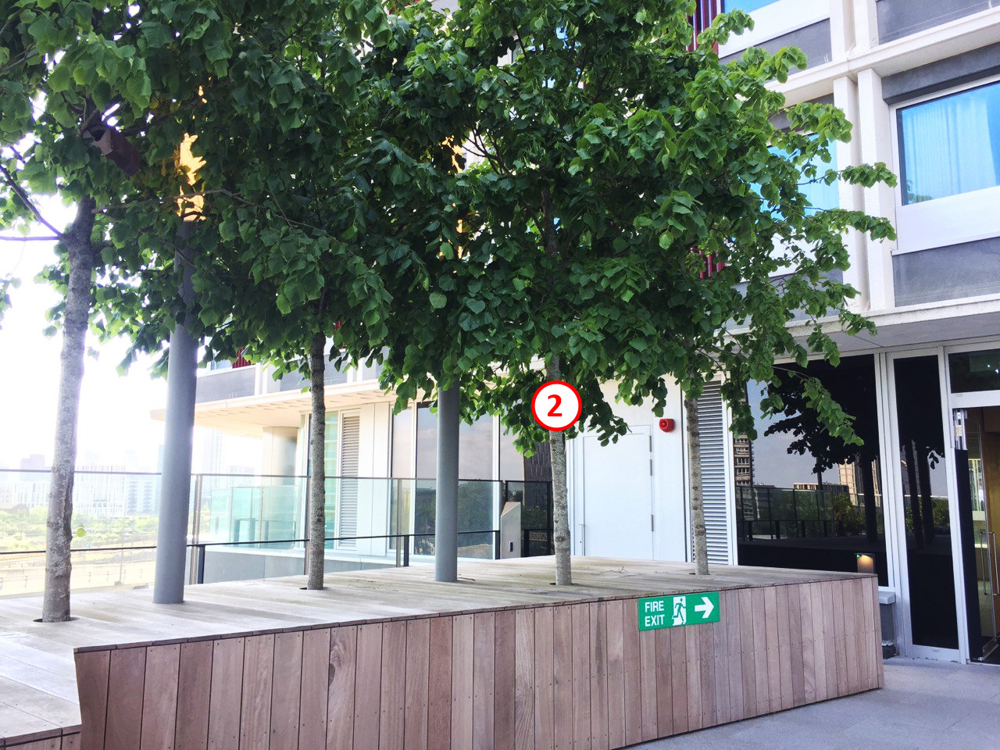

Figure 6 – Point 2 in OPS building on one of the trees in front of Tower 1 entrance.

### Point (3)

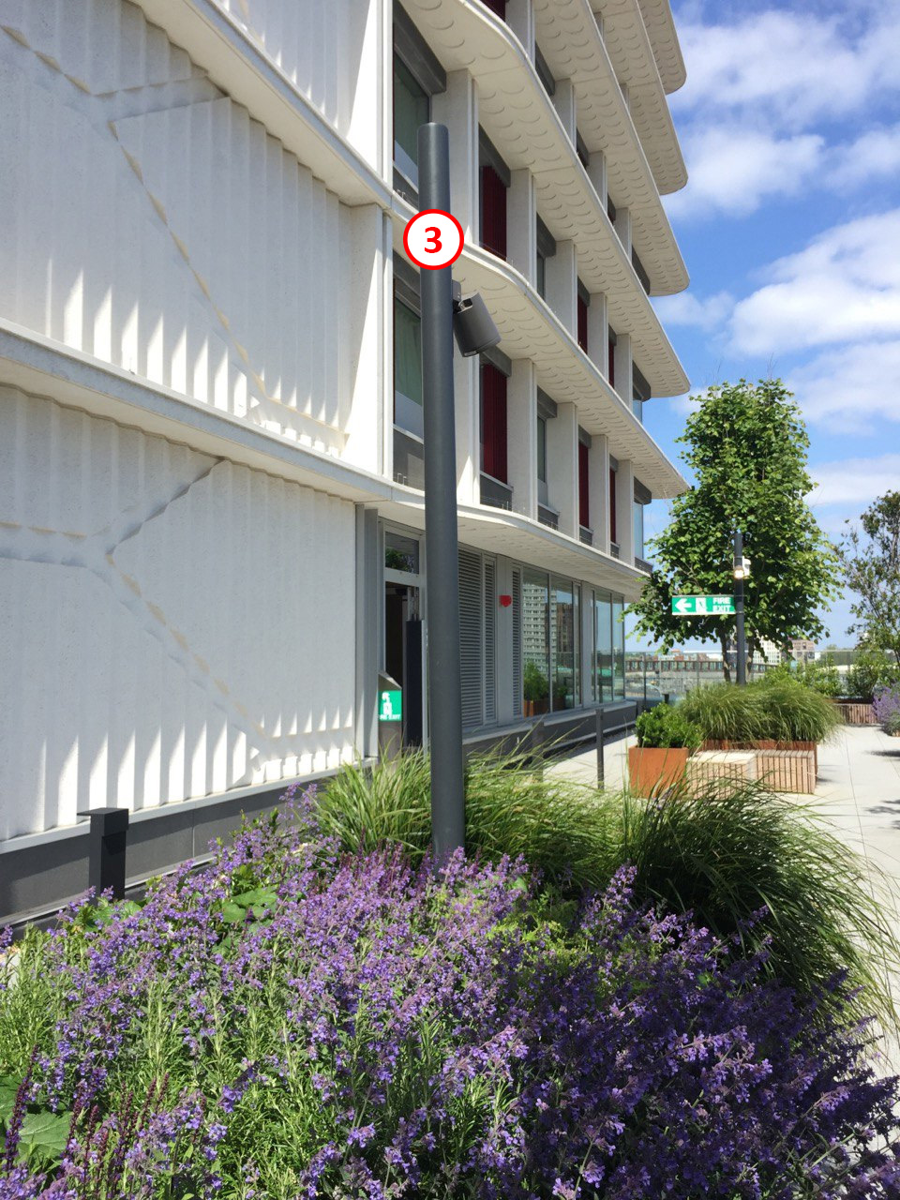

Figure 7 – Point 3 in OPS building on one of the poles in front of Tower 2 entrance.

## **Production phase deployment**

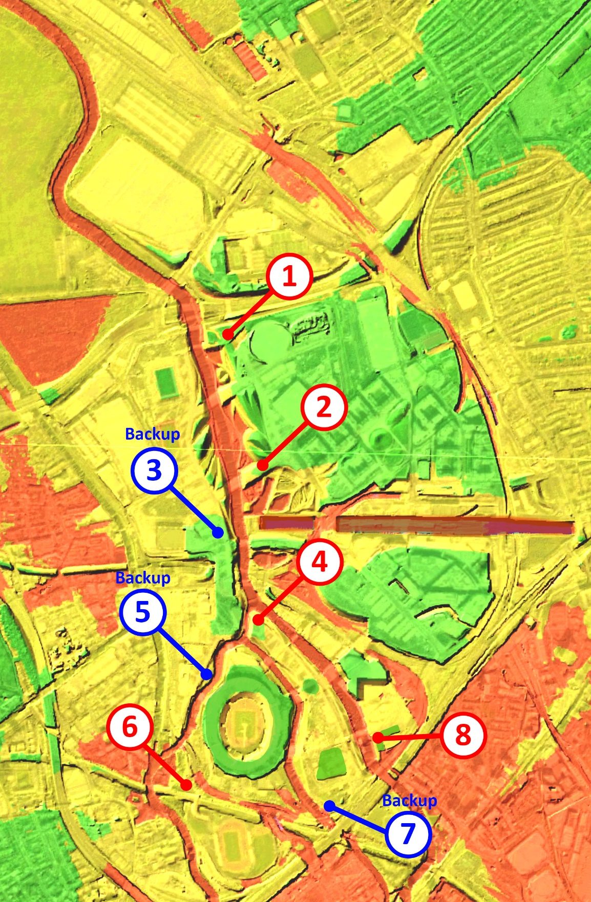

Figure 8 – Production deployment map. **Red**: main nodes, **Blue**: backup nodes (not deployed unless needed)

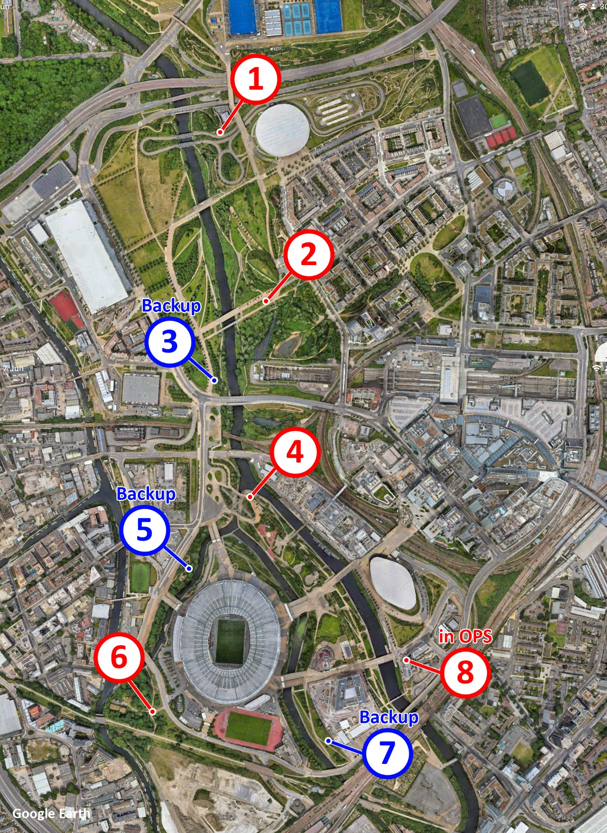

Figure 9 – Production deployment map with satellite view. **Red**: main nodes, **Blue**: backup nodes (not deployed unless needed)

### Point (1)

* Location: <https://goo.gl/maps/YNMeKN5nr37m1fR5A>

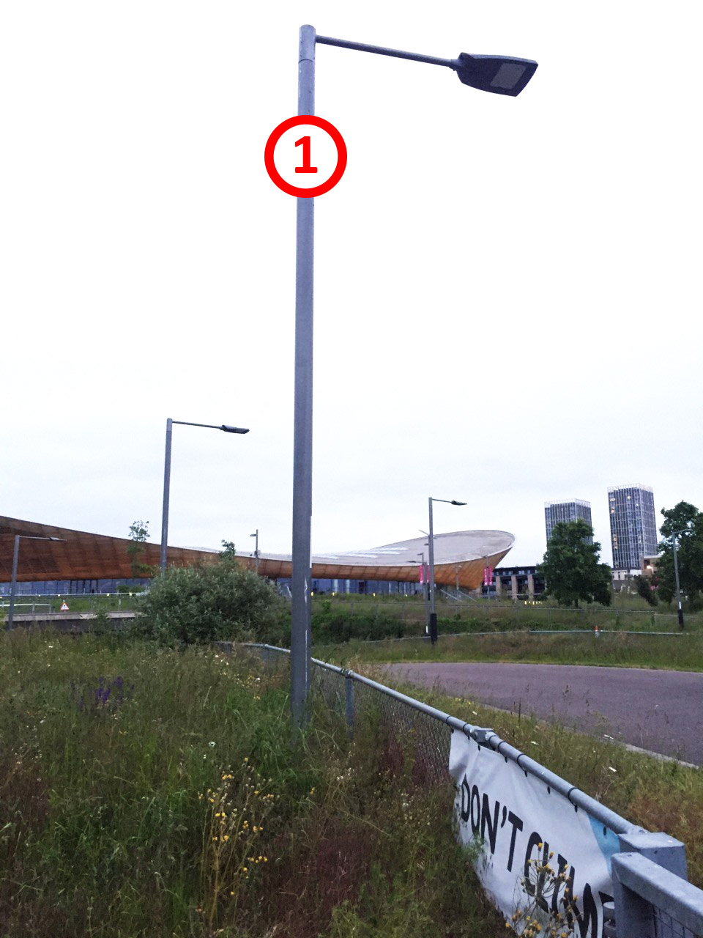

Figure 10 – Point 1 location on a pole.

### Point (2)

* Location: <https://goo.gl/maps/mALEXZ7BXhwmcBoG6>

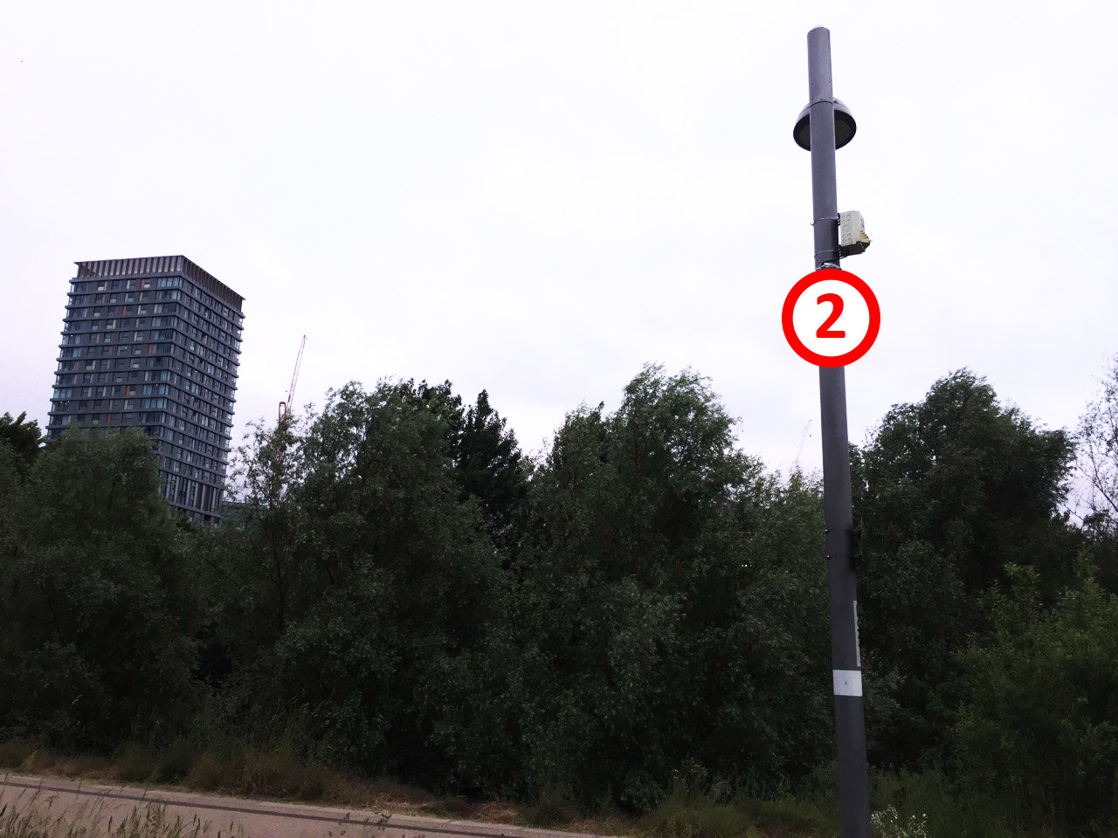

Figure 11 – Point 2 location on a pole.

### Point (3) - Backup

* Location: <https://goo.gl/maps/Z2oBSPZrigR1RN759>

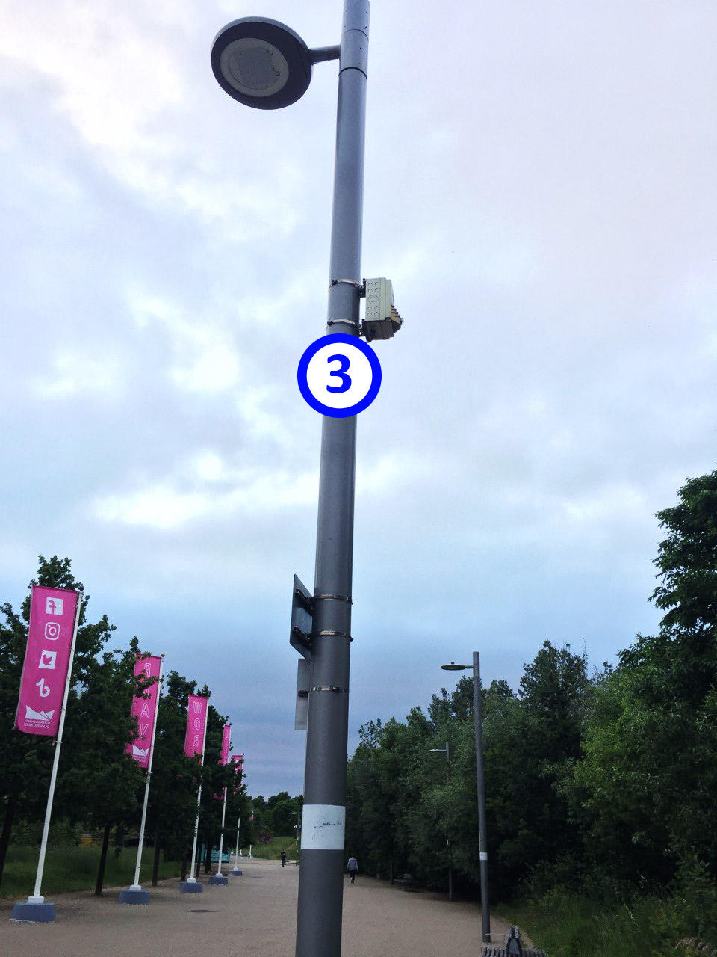

Figure 12 – Backup Point 3 location on a pole.

### Point (4)

* Location: <https://goo.gl/maps/7PVEuoVChoAWNGfV8>

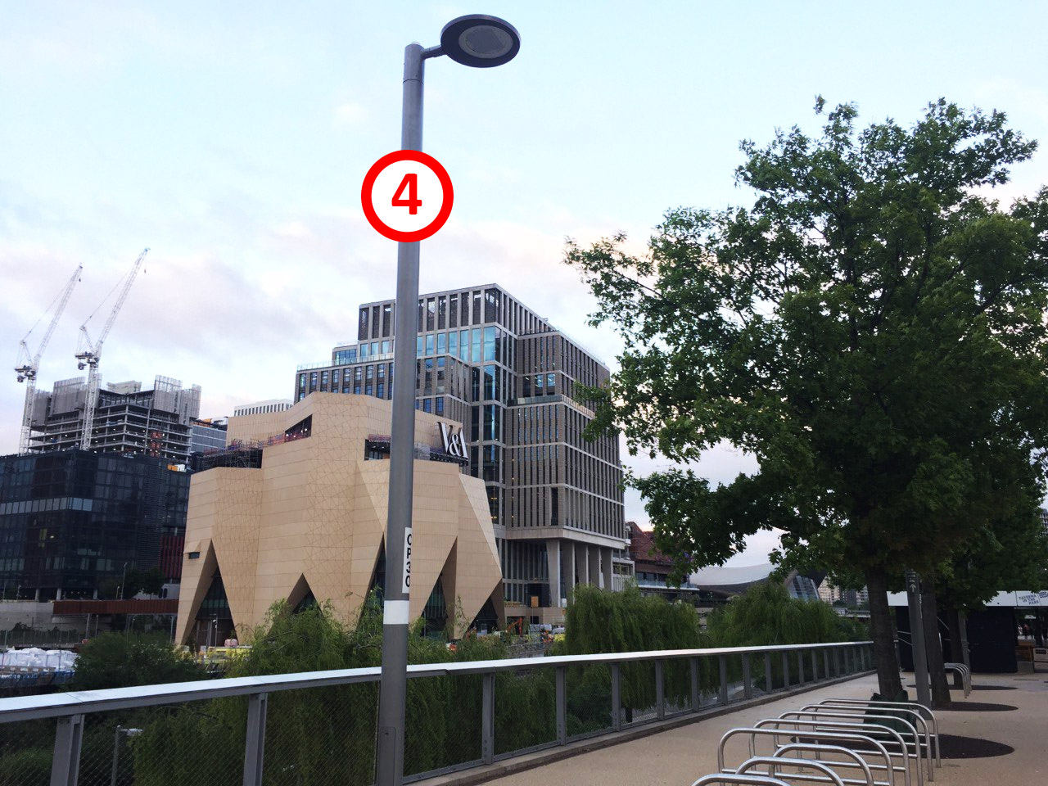

Figure 13 – Point 4 location on a pole.

### Point (5) - Backup

* Location: <https://goo.gl/maps/dpDjeVB95uoZ5SFZ6>

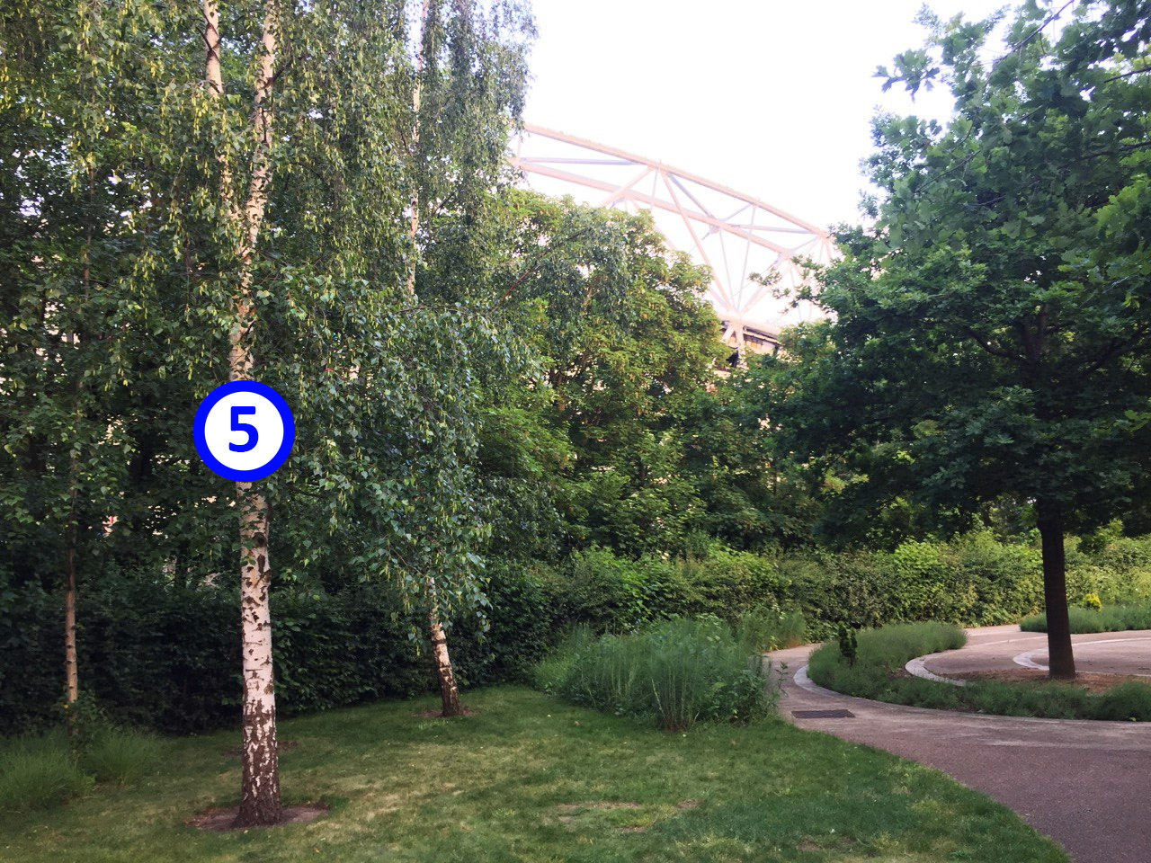

Figure 14 – Backup Point 5 location on a tree.

### Point (6)

* Location: <https://goo.gl/maps/GrhahYLZUaSXHNdu5>

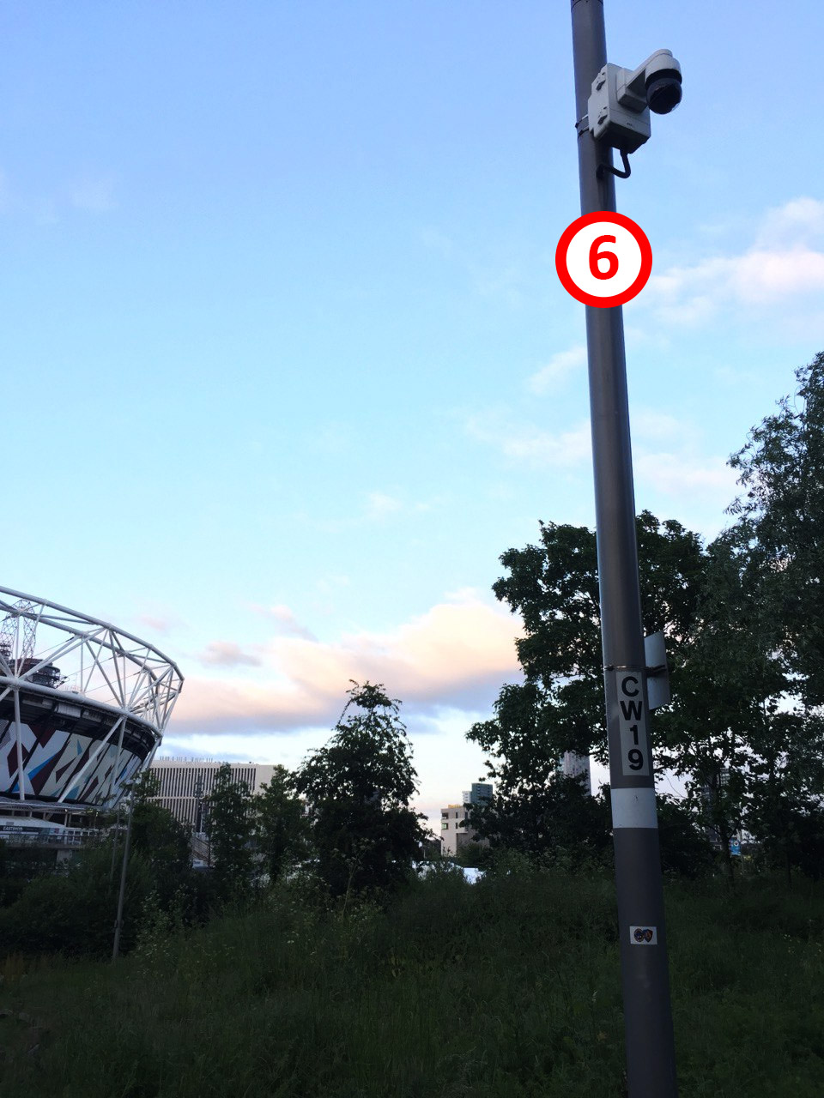

Figure 15 – Point 6 location on a pole.

### Point (7) - Backup

* Location: <https://goo.gl/maps/U4n7qcVpkv3vwTKt6>

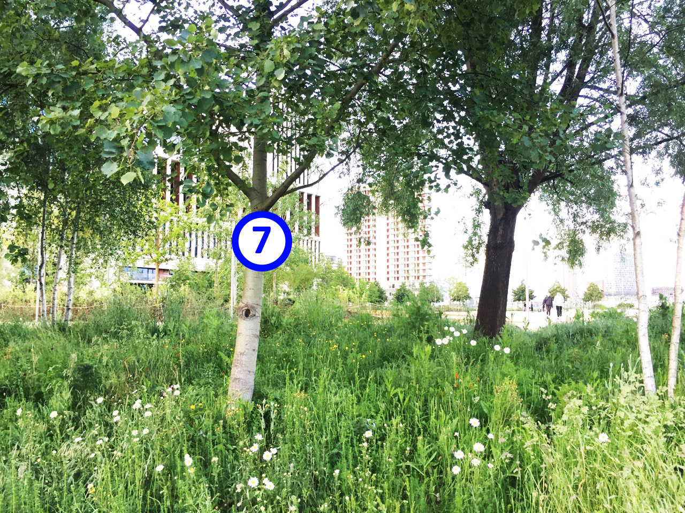

Figure 16 – Backup Point 7 location on a tree.

### Point (8)

In OPS top floor, same as Point 1 in Phase (1): testing phase.